WILDLIFE ACTS 1976 TO 2018 – SECTIONS 22 (9)(b)
LICENCE TO HUNT PEN-REARED BIRDS

1. Name of applicant:
Address:
[BLOCK LETTERS] |  |  | Eircode:
Email Address:
Telephone No.:
2. Species Name: (Common & Scientific)
3. Number of birds to be released:
6. Purpose of capture or killing:
7. Area(s) in which applicant will operate:
(e.g. county and townland).

8. Confirmation all licensees are legally entitled to use shotguns. Yes/No
9. Qualifications/experience in this field of activity:
- Organisation to which applicant is
affiliated:
11. Period for which licence is required:
12. Number of previous licence (if any) and date of expiry:
I declare that the above particulars are, to the best of my knowledge and belief, true and correct.
Signature: ……………………………………………………………… |  |  |  |  | Date: ……………………………………..
Please return completed  application form to:  Wildlife Licensing Unit (R. 2.03)  National Parks & Wildlife Service  90 King Street North  Smithfield  Dublin 7  D07 N7CV  e-mail: wildlifelicence@housing.gov.ie |  |  |  | 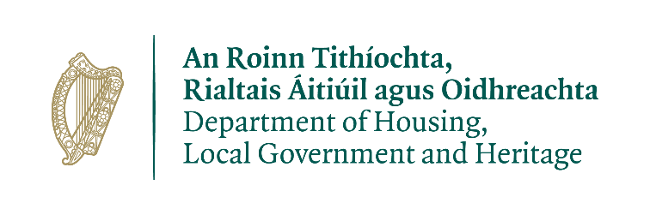

Please note that under Data Protection legislation, Department staff may only discuss licence applications with the applicant and not with any third party. See Privacy Statement at www.npws.ie/licences

