WILDLIFE ACTS 1976 TO 2018 – SECTION 42
APPLICATION FOR PERMISSION TO CONTROL PROTECTED WILD BIRDS OR
PROTECTED WILD ANIMALS CAUSING SERIOUS DAMAGE
PLEASE COMPLETE IN FULL, IN BLOCK CAPITALS (any incomplete forms will be returned to applicant)
- Name of applicant:  Address: (in full include Post Code)  Email address:  Telephone no: (Landline/Mobile)  - Nominated Stalker(s) Name :  Address:  Telephone no: (Landline/Mobile)  - Species of bird or animal causing damage:  - Particulars of damage caused.  - Description and location of property being damaged. Please state exact Townland(s)  and county.  6. State whether it is proposed to capture or  kill the bird or animal.  - Proposed means of capturing or killing. If a poison / stupefying bait is being applied for state name of poison / bait.  - Description of any firearm(s) and ammunition to be used.  - How is it proposed to dispose of the bird or animal when captured or killed?  - Period for which permission is required.  - Number and date of issue of previously held permission (if any):  (Relevant to deer only)  - Current Deer Hunting Licence Number.  - Area map(s) must be included.  (A six inch Color OS map with the Name, Address, Townland(s) Parcel Number(s) |  | ………………………………………………………………………………………….  ………………………………………………………………………………………….  ……………………………………………………… Eircode:…………………  ………………………………………………………………………………………….  ………………………………………………………………………………………….  ………………………………………………………………………………………….  …………………………………………………………………………………………..  …………………………………………………………………………………………..  ………………………………………………………… Eircode:………………  ………………………………………………………………………………………….  …………………………………………………………………………………………..  …………………………………………………………………………………………..  …………………………………………………………………………………………..  …………………………………………………………………………………………..  …………………………………………………………………………………………..  …………………………………………………………………………………………..  ……………………………………………………………………………………………  ………………………………………………………………………………………….  …………………………………………………………………………………………  ………………………………………………………………………………………..  ………………………………………………………………………………………..  …………………………………………………………………………………………  ……………………………………………………………………………………….  - Copy of Competency Cert(s) DMQ1 or HCAP must be  included if use of lamp is requested, and must be stated on the application form.  If more space is required please attach a separate sheet to application

TERMS AND CONDITIONS OF PERMISSION

If this application for permission is granted, I, the applicant, hereby undertake to comply with and observe the terms and conditions set out hereunder:

(a) The Minister may withdraw the permission at any time.

(b) I shall, if requested by the Minister, remedy any matter which the Minister considers to be a breach of the permission by me.

(c) The Minister shall not be held liable for losses, injuries, or damage to persons or property arising out of the exercise of this Permission and I shall indemnify and keep indemnified the Minister, his successors, employees, agents and assigns against all actions, claims, demands and costs in respect of any such losses, injuries, accidents or damage.

(d) The Permission shall be produced for inspection on request being made by a member of the Garda Síochana or any person appointed by the Minister under Section 72 of the Wildlife Acts 1976 to 2018 to be an authorised person for the purposes of the said Act.

(e) A return giving particulars of the species and number of protected wild birds or protected wild animals captured, killed or otherwise controlled pursuant to the Permission shall be made to the NPWS on expiry of the period of validity of the Permission or on a request being made in that behalf by the Minister.

(f) I shall comply with any other terms or conditions which the Minister may see fit to apply and which are notified to me in writing.

(g) Dated this day of 202__

Signature of Applicant:
Please return completed  application form to:  Wildlife Licensing Unit (R. 2.03)  National Parks and Wildlife Service  90 King Street North  Smithfield  Dublin 7  D07 N7CV  Email: wildlifelicence@npws.gov.ie |  | 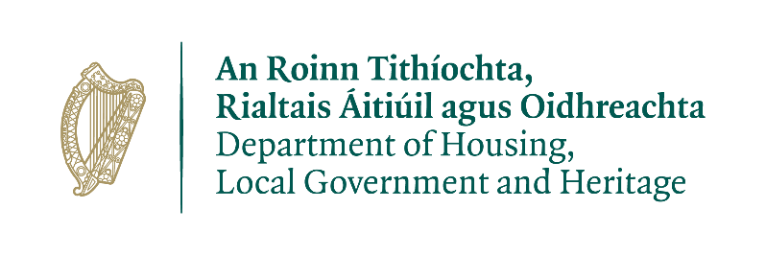
License application under the Wildlife Act 1976 to 2018
PRIVACY STATEMENT

Please note that under Data Protection legislation Department staff may only discuss licence applications with the applicant, and not a third party. See Privacy Statement at www.npws.ie/licences

