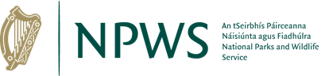

Wildlife Acts 1976 TO 2018 –
Section 41
Application to Amend an Existing Bird of Prey Possession Licence(s)

Prepared by the National Parks and Wildlife Service
npws.ie

- This application to be completed by all applicants.
- Please use legible BLOCK LETTERS and answer ALL questions.
- To avoid unnecessary delay in processing your application, please ensure that you have fully completed this form and that you have included a current email address.
Please return your completed forms by email or post:
Email: wildlifelicence@npws.gov.ie
Post: Wildlife Licensing Unit
National Parks and Wildlife Service
Department of Housing, Local Government and Heritage
90 King North Street
Smithfield
Dublin 7,
D07 N7CV

Privacy Statement
Please note that under Data Protection legislation Department staff may only discuss licence applications with the applicant, and not with any third party. See Privacy Statement at www.npws.ie/licences

- Personal Details
Full Name: ________________________________________________________
Current Licence Number
Address Line 1
Address Line 2
County
Eircode
Daytime Phone No.
Email

- To ADD a bird to your licence
Please provide full name, address and phone number of proposed bird provider.
If the bird has no ring/identification number, please state this in the space provided.
Species | Age | Sex | Details of Proposed Provider of Bird | Ring Number & Microchip Details

Part 3. To REMOVE a bird from your licence
If the bird has no ring/identification number, please state this in the space provided.
Species | Age | Sex | Ring Number & Microchip Details | Reason for Removal from Licence

Part 4. Declaration
I declare that all of the foregoing particulars are, to the best of my knowledge and belief, true and correct.

Signature Of Applicant:_______________________ Date: ___ / ___ / ______
Any person who, for the purposes of obtaining a licence under the Wildlife Acts 1976 to 2018 makes any statement or gives information which they know to be false shall be guilty of an offence. Penalties, on conviction include fines and forfeiture of firearms.

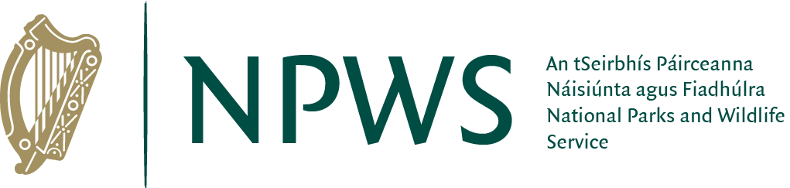
npws.ie
National Parks and Wildlife Service

