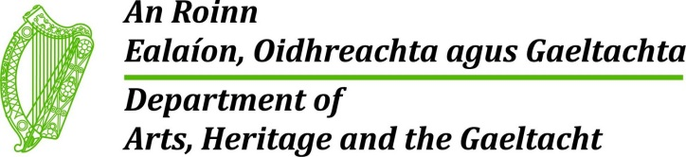
Ireland will tomorrow (Thursday) mark World Wildlife Day. World Wildlife Day is a United Nations initiative that coincides with the anniversary of the signature of the Convention on International Trade in Endangered Species (CITES), an international agreement between governments to regulate international trade in wild species of animals and plants to ensure that their survival does not become threatened by such trade.
World Wildlife Day will be celebrated in 2016 under the theme “The future of wildlife is in our hands.” African and Asian elephants will be a main focus of the Day under the theme “The future of elephants is in our hands”.
The world’s wildlife faces many challenges, particularly from illegal trade. It is estimated that the annual value of illicit wildlife trafficking is up to USD 20 billion a year ranking it amongst other serious transnational crimes such as the trafficking in people, drugs and arms. Poaching and trafficking in wildlife, driven by organized crime groups, pose the most immediate threat to many iconic species including elephants, pangolins, rhinoceros, sharks, tigers and precious tree species. A spike in organised wildlife crime since 2007 has seen poaching levels of rhino for their horns soar by 900% in South Africa, while around 100,000 elephants were estimated to have been slaughtered for their ivory between 2010 and 2012.
To address these problems, governments, law makers, enforcement officers, customs officials and park rangers around the world are stepping up their efforts to protect wildlife. On Friday the 26th of February the European Commission adopted an EU Action Plan to tackle wildlife trafficking within the EU and strengthen the EU’s role in the global fight against these illegal activities. This Action Plan is an ambitious one that seeks to crack down on what has become one of the most profitable criminal activities worldwide.
However, while some positive progress is being made to tackle illicit wildlife trafficking, it is up to each and every one of us to play our part in protecting wildlife and habitats. Our collective conservation actions can be the difference between a species surviving or disappearing for good.
Therefore, the Minister would like to invite all organisations and individuals to get involved and celebrate this day. Information on how you can get involved in World Wildlife Day can be found on www.wildlifeday.org, where you can download various posters and help promote various social media campaigns.
For further information on the implementation of CITES in Ireland please see www.npws.ie or contact the National Parks and Wildlife Service, which is the CITES authority for Ireland (cites@ahg.gov.ie).

