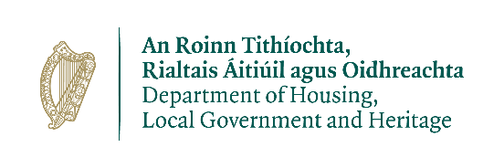

Wildlife Acts 1976 TO 2018 –
Section 22 (9) (C)
APPLICATION FOR LICENCE TO HUNT PROTECTED WILD BIRDS FOR THE PURPOSE OF EITHER TRAINING GUN DOGS FOR ANY FIELD SPORT OR HOLDING GUN DOG TRIALS

Prepared by the Department of Housing, Local Government and Heritage
npws.ie

- This application to be completed by all applicants.
- Please use legible BLOCK LETTERS and answer ALL questions.
- To avoid unnecessary delay in processing your application, please ensure that you have fully completed this form and that you have included a current email address.
- If you have previously held a licence, you must submit returns to the address below.
Please return your completed forms by email or post:
Email: wildlifelicence@npws.gov.ie
Post: Wildlife Licensing Unit
National Parks and Wildlife Service
Department of Housing, Local Government and Heritage
90 King North Street
Smithfield
Dublin 7,
D07 N7CV

Privacy Statement
Please note that under Data Protection legislation Wildlife Licencing Unit staff may only discuss licence applications with the applicant, and not with any third party. See Privacy Statement at www.npws.ie/licences

- Personal Details
Full Name: _______________________________________________________
Address Line 1
Address Line 2
County
Eircode
Phone No.
Email
Organisation to which you are affiliated
Period for which licence is required
Previous licence’s number (if any) and expiry date

Part 2. Species and Hunting Details
Species Name (Common & Scientific)
Numbers to be Hunted
Capture or Killing?
Purpose of Hunting
Areas in which applicant will operate (e.g. townland & county)
Means of Hunting
Type of trap, snare or net (if appropriate)

Part 3. Qualification and Experience in this field of activity
Give specific details

Part 4. Declaration
I declare that all of the foregoing particulars are, to the best of my knowledge and belief, true and correct.
Signature Of Applicant:_______________________ Date: ___ / ___ / ______
Any person who, for the purposes of obtaining a licence under the Wildlife Acts 1976 to 2018 makes any statement or gives information which they know to be false shall be guilty of an offence. Penalties, on conviction include fines and forfeiture of firearms.

npws.ie
Department of Housing, Local Government and Heritage

