WILDLIFE ACTS 1976 TO 2018 – SECTIONS 22 AND 34

APPLICATION FOR LICENCE TO CAPTURE AND/OR HUMANELY KILL A PROTECTED WILD BIRD FOR EDUCATIONAL, SCIENTIFIC OR OTHER PURPOSES

1. Name of applicant:
Address:
[BLOCK LETTERS] |  |  | Eircode:
Email Address:
Telephone No.:
2. Species Name: (Common & Scientific)
3. Number to be captured or killed:
(please specify whether capture or killing)
4. Purpose of capture or killing:
5. Area(s) in which applicant will operate:
(e.g. county and townland)
6. Means of capture or killing:
7. Type of trap snare or net (if appropriate)
8. Qualifications/experience in this field of activity
9. Organisation to which applicant is affiliated:
10.Period for which licence is required:
11.Number of previous licence (if any) and date of expiry:
I declare that the above particulars are, to the best of my knowledge and belief, true and correct.
Signature: ……………………………………………………………… |  |  |  |  | Date: ……………………………………..
Please return completed  application form to:  Wildlife Licensing Unit (R. 2.03)  National Parks & Wildlife Service  90 King Street North  Smithfield  Dublin 7  D07 N7CV  Email: wildlifelicence@npws.gov.ie |  |  |  | 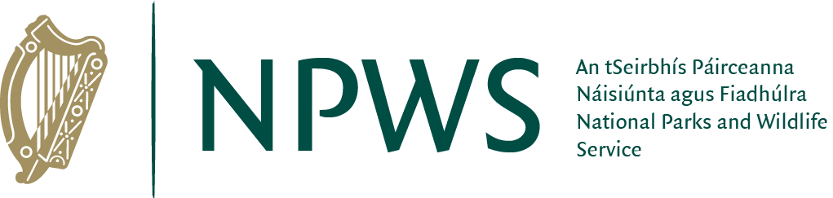

License application under the Wildlife Act 1976 to 2018
PRIVACY STATEMENT

Please note that under Data Protection legislation Department staff may only discuss licence applications with the applicant, and not with any third party. See Privacy Statement at www.npws.ie/licences

